To:
From:
Subject:

Plate corrugations
One of the biggest changes manufacturers have made to the gasketed plate heat exchanger (GPHE) technology in recent years is the design of the plate corrugations. The corrugations are what control flow distribution and turbulence within the unit. There is a dead spot on most plates that is prone to fouling and where heat transfer is poor. See attached screen shot at the bottom of the email - red circles. Alfa Laval has redesigned the corrugations and port on the plate to eliminate this dead spot. Recapturing this dead space and turning it into effective heat transfer area means you can use fewer plates. The corrugations also produce more turbulence, which means a higher heat transfer coefficient and less surface area required. In some cases, this new plate design will allow you to reduce the surface area by 20% when compared to the original unit.
Here is an animation on the CurveFlow: https://www.youtube.com/watch?v=TxiG3Y0Pnqk

Alfa Laval uses two different corrugation patterns per model - high and low theta - which describes the angle of the "V" on the plates. Think of the V (theta) as a speed bump. The more obtuse angle is the high theta plate and will provide more resistance to the fluid. The more acute angle is the low theta and will provide less resistance. Unless we are dealing with a viscous fluid where a mixed plate pack could negatively affect flow distribution, we mix the two types of plates to optimize both U-value and dP.

AHRI
Alfa Laval takes pride in the quality of its designs. We are more conservative than most manufactures. In the mid-late 90's we became heavily involved in AHRI, which is a third-party certification of GPHEs. AHRI takes a manufacture's design software and tests a sampling of their GPHEs against the algorithms for heat transfer and differential pressure. You pass if you are within 95% of the predicted heat load and 115% of the predicted differential pressure. Alfa Laval designs to zero tolerance - always. Many mfgs do not - they will take advantage of the tolerances that AHRI allows. AHRI eliminates the games that mfgs play. We strongly recommend AHRI certification for Mission Critical designs.

Features and benefits
Many of the other changes that Alfa Laval has made allow the GPHE to be serviced more easily/effectively.
- ClipGrip gaskets - the gaskets do not tangle as easily and are less cumbersome to install/replace
- Swing feet - simpler to pull PHE and less prone to jamming - https://www.youtube.com/watch?v=sKDDeLQz9FI
- Roller bar on the pressure plate - https://www.youtube.com/watch?v=qTG3sfsGOUw
- Five-point alignment system - https://www.youtube.com/watch?v=SPJvl4A0xFQ
- Bearing boxes on tightening bolts - https://www.youtube.com/watch?v=xiDKpU72TMY

Optional features
- Insulation to reduce condensation on the exterior of the unit.
- Port filter for poor water quality. Requires inspection ports on frame plate.
- Cleaning in Place (CIP) - portable cleaning module.

Best design practices
Turbulence - The performance of a plate and frame heat exchanger (heat transfer and fouling resistance) is dependent upon the level of turbulence achieved within the unit. The transition from laminar flow to turbulent flow occurs at a Reynolds number of 2200; the Reynolds number is directly proportional to the fluid velocity. The fluid velocity through the channel is calculated by dividing the flow rate through the hxr by the cross section of the "pipe" or size of the plate pack. If you increase the cross section of the "pipe" (add plates or units in parallel), at a constant flow, your velocity will decrease, therefore your turbulence will also decrease. If your turbulence decreases, your heat transfer coefficient and wall shear stress (see Fouling) will suffer. Many folks believe that throwing additional surface area at the hxr will provide them with a safety buffer, but the opposite occurs b/c it affects the turbulence.

Fouling - We do not use fouling factors. A traditional fouling factor of 0.0005 will increase the surface area by approximately 35%, which per the above explanation, will decrease the channel velocity. In one example, this additional 35% took what would have been a U-value of 1100 Btu/ft²-hr-F and reduced it to 700 Btu/ft²-hr-F. If you must have excess area, use 10%. If fouling is a concern, the more important parameter to maintain is wall shear stress. Wall shear stress is the force the fluid exerts on the plate to keep particulates suspended in the stream and is directly proportional to the dP. The target wall shear stress for a fouling application = 50 Pa, min 35 Pa. We can usually achieve 50 Pa with a dP of ~10 psi. As a secondary defence against fouling, we recommend using some type of filtration. The mesh on the filter should be ~75% of the open channel spacing.

Temperature approach - The last couple tenths of a degree are exponentially more difficult to achieve. If you can open up the approach even 0.1-0.2°F, you can greatly reduce the surface area required.

Connection velocity - Target connection velocity = 8-10 ft/s, up to ~15 ft/s for a retrofit (like pipe velocity). If you are comparing GPHE bids and one mfg is quoting a 6" connection and another is quoting an 8" connection, you should inquire about the connection velocity, which takes me to the next topic - %dP lost in the connections.

% of dP lost in the connections - dP is your driving force. If you take too much dP to get the fluid through the connection and to the first plate, you will not have enough driving force to push the liquid through the entirety of the plate pack, effectively cutting your surface area by X. To ensure proper plate pack distribution, limit %dP lost in connections to 30-35% of total dP across the heat exchanger.

Minimum plate thickness - This is driven by how the mfg presses its plates and the required design pressure. Master specification states that plates material must be 0.0254" before pressing. This is b/c many mfgs press in multiple stages, leading to thin spots on the plate. Alfa Laval presses its plates in a single stage so does not need this extra tolerance. For most HVAC cooling applications 0.4 mm plates are more than adequate for a 150 psi design pressure.

Try to put as much info on the schedule as possible: heat load, surface area, LMTD, dP, %dP lost in the connections, connection velocity, wall shear stress, weight, dimensions etc.

We respect that many end users wish to standardize on a single design. Doing so can unfortunately create operational as well as maintenance issues. GPHEs will transfer heat regardless of the operating conditions, however they are designed to perform optimally at one set of conditions. When the heat exchanger is operated outside of these conditions, the potential for problems begins to increase, primarily fouling. This is not to say that GPHEs cannot handle fluctuating operating conditions, only that we must be fully aware of how the heat exchangers will be used so that we can analyse all scenarios and provide you with the best solution.

Alfa Laval Insight features and movies
For the offered gasketed plate heat exchangers we would like to take the opportunity to highlight some of the key features of our products.

Frame related features
Bearing box
- Ball bearing inside – reduce frication
- Possible to open and close GPHE on 4 tightening bolts only (6 on large GPHEs)
- Faster maintenance – reduced maintenance cost
- Less risk of paint damage on frame plate – reduce spare cost

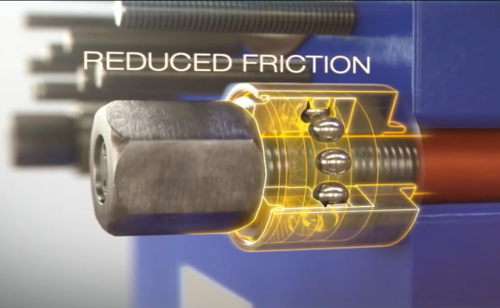
Figure 1 Click on Picture to see movie

Elongated nuts
- Reduced risk of overheating and seizure of nut
- Trouble free service
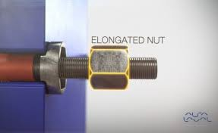


Click on Picture to see movie

Fixed bolt head
- Bolt is fixed to tightening bolt under any condition
- Trouble free service
- Safe to do service
- Glued designs are less reliable

Click on Picture to see movie

Key holt bolt opening
- Smaller foot print including service area
- Faster service – reduced maintenance cost
- Bolt holes closed from the side are standard on some other manufacturers GPHEs
Click on Picture to see movie

Lock washer
- The tightening bolt can be opened & closed from one side (no rotation)
- Faster maintenance – reduced maintenance costs
- Reduces risk that the tightening bolts fall out – safety
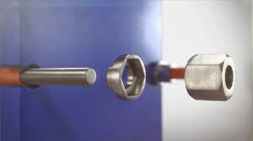
- Many other manufacturers deliver the bolts with standard flat washer
Click on Picture to see movie

Pressure plate roller
- High quality steel – reduced risk of corrosion
- Steel and not plastic – reduced risk of breakdown
- Faster service – reduced maintenance cost
- Many other manufacturers rollers corrode
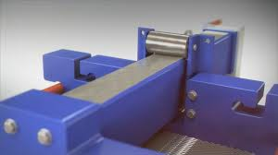
Click on Picture to see movie

Pressure plate roller on T-bar
- No corrosion on metal roller or T bar – reduced maintenance cost
- Roller protected under carrying bar
- Fits in areas with limited space because of lower height
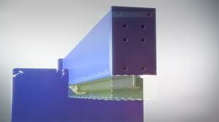
Click on Picture to see movie

Tightening bolt cover
- Reduced risk of corrosion & stuck tightening bolts
- The nut is locked in the lock washer & the lip prevents it from rotation
- Faster maintenance – reduced maintenance cost
- Longer life time of tightening bolts – reduced spare costs
- Many other manufacturers deliver without bolt protection
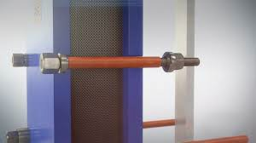
Click on Picture to see movie

Plate related features

Distribution area Chocolate pattern
- Avoid mal-distribution and fouling build up
- Lowest Possible pressure drop
- Maximization of heat transfer area
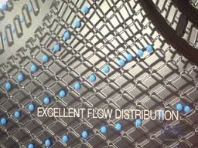
- Reduced fouling – longer running time

Click on Picture to see movie

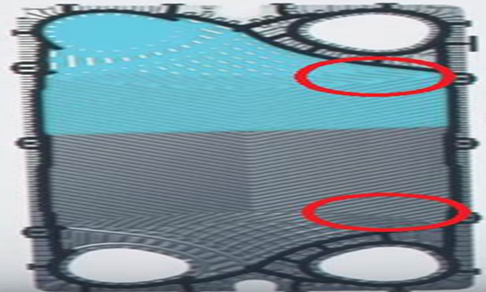

Gasket profile
- Gasket profile tailored to fit the plate type and thickness – longer lifetime of gaskets and plates
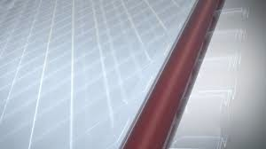
Click on Picture to see movie

Leak chamber
- Early leak indication – minimize intermixing of fluids
- Avoids corrosion on plate – reduce spare parts
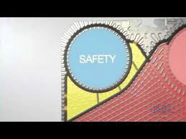
Click on Picture to see movie

Reinforced hanger
- Perfect alignment
- To avoid plate damage
- Easy to service

Click on Picture to see movie

Five-point alignment
- Five contact points between the plate and the carrying and guiding bar.
- This system ensures a perfect alignment of the plate pack, and facilitates the retightening of the plates after maintenance
- Plates perfectly in place during the critical closing procedure of the plate heat exchanger
- Exact fit – no snaking or leaks
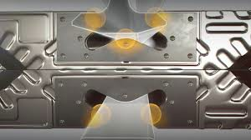
Click on Picture to see movie

